Potion Dice – Rulebook

Dear students, welcome to our school of magic.
You are challenged to brew various magic potions.
These potions have different effects that you can use immediately or later for your further training and drinks.

The Material

1. The game board
Let's take a look at the game board first.
You have 2 free spaces for your drinks and one space for 3 ingredients.

The Game Board

2. The Round Counter.
We set the round counter to 1 for the first round.
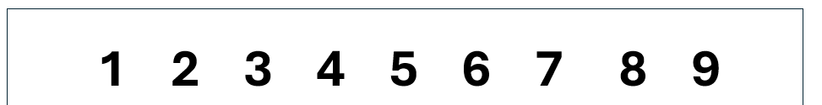

3. Dices
Everybody gets 15 dices.

4. The Potions.
From the potions, we first select all cards with a star in the upper right corner. Example:
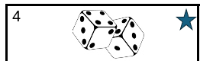
We refer to these as starting potions.

5. Additional Material

We set aside the small aids and awards. These will be used during the game.
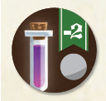

Awards small aids

How to Play

Preparation
Each player receives:
a game board called a work table

15 dice
The round counter is set to 1 (1st round) out of 9.

The starting cards are shuffled and 4 are laid out face up with the dice sides showing. (As a reminder, these were the potions with a star in the upper right corner).
Starting with the starting player, a card is chosen clockwise. Once the card has been chosen, a new one is immediately added so that there are always 4 to choose from. We do this until the last player. Then, starting with the last player, we continue counterclockwise until everyone has 2 potions on their game board. The starting potions are now removed from the game and the other potions come into play. Here, too, players can always choose from 4 potions.
Now we can start the game.
First take a look at the cards:

The type of magic potion (what it can do once). For details, see the description of the potions.

Special marking (only a star for the starting card).

Which ingredients are needed for this potion and in what quantities.

Front
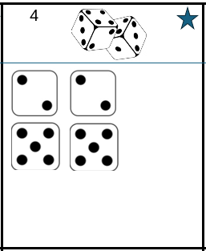
The victory points if the potion is ready at the end of the game.

The type of magic potion (what it can do once). For details, see the description of the potions.

Special marking (only a star for the starting card).

Which ingredients are needed for this potion and in what quantities.

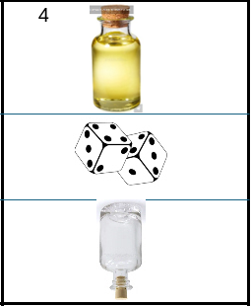
Back

The victory point, because the potion is ready.

Full bottle facing up: This potion can be used.

The type of magic potion (what it can do once). For details, see the description of the potions.

If the empty bottle is facing up: This potion has already been emptied.

The Actions
At the preparation table

- When it is your turn, you can place the dice from your reserve and dice from one or both potions ready for rolling. These are now the free dice.
- When it is your turn, you roll the free dice. At the beginning, this are all 15 dices. You roll all free dice. All dice showing a 6 are placed directly on the table. These cannot be used in the rest of the round, unless explicitly allowed by a potion.
- You can choose a number (1-5) and then must place all dice with that number. If that number has already been placed, you cannot place any more dice with that number. Numbers from your reserve and those already on potions do not count, only those on your preparation table!
- You must continue rolling the dice as long as you can place a number and have dice. If you cannot do so, your turn is over. The remaining dice are added to the sixes and remain on the preparation table.

At the work table:
Now you can distribute your ingredients among the drinks.
Once a potion is ready, set it aside. The dice used to make it are returned to the work table. You can use this potion in this turn, just like the other finished potions, once per game. To do so, use the back of the card. For potions that have not yet been used, the full bottle faces up. For used potions, the empty bottle is still facing up.
You can also use a small aid once per round to turn a remaining die to a desired number and distribute it.
If there are still dice left, up to 3 must be selected and placed in the reserve. All others are added to the remaining dice. If there are fewer or none left, they are placed in the reserve.
Now you can check whether you have earned an award. (See Awards)
Free spaces on the work table can now be filled with new potions from the center. After a selection, the space is always filled directly to 4.
No further actions are allowed!

You can also use a small aid once per round to turn a remaining die to a desired number and distribute it.
If there are still dice left, up to 3 must be selected and placed in the reserve. All others are added to the remaining dice. If there are fewer or none left, they must be placed in the reserve.
Now you can check whether you have earned an award. (See Awards)
Free spaces on the work table can now be filled with new potions from the center. After a selection, the space is always filled directly to 4.
No further actions are allowed!

When everyone has had a turn in clockwise order, the next round begins. The round indicator moves forward 1 space.

End of the Game
The Game ends after the 9th round
Now count all Points of your Potions, 4 Points for each Awards and -2 Points for each little help. The guy with the most points win.

Awards:
Those who work hard will be rewarded with awards. These are worth 4 points at the end of the game.
See the 4 on the green ribbon
Awards are given when you:
- Have brewed 6 different potions (the 7th and subsequent different potions do not earn any further awards!) or
- 3 potions of one type (the 4th and subsequent potions of this type do not earn any further awards, but 3 potions of a different type do!)
One potion can count both for the different potions and for the potions of one type.

Types of magic potions
The following applies to all potions:
They can only be used once per game. After that, turn them from a full bottle to an empty bottle!

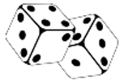
Reroll
Any 2 dice that have just been rolled (including 6s) can be rerolled once.
Several different types of these potions, as with all potions, can be used once. (To use in the preparation table)


Blind Love.
With this potion, you can take up to 2 dice from any other player's reserve and roll them. These can be used in your turn.
At the end of the potion user's turn, the same number of dice must be returned to the selected player. They roll these again and place them in their reserve.


Resurrection
With this potion, you can place a rolled 6 on your preparation table as any number you wish.
The number is either added to a row of numbers already laid out or forms a new row to which nothing else is added from the dice roll.


Number changer.
This potion allows me to change another die on my work table into any other number.
Since 6s remain on the preparation table, this can never be a 6, but only a 1–5.


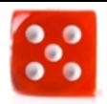
Virtual dice
This potion represents one of these virtual dice.
This potion is then a die with this number. It must be used on the work table when preparing it, as the last die of this number.


Magical Refill
With this potion, I can refill another potion. This potion is then empty. Another potion is full again and can be used again.
This is the only way that another potion can be used multiple times.

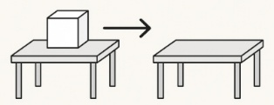
Trick
Return any die from another player's work table to the preparation table. This die can be placed on a potion that is not yet finished or in the reserve.

